A SERVICES ARM : M/S PACE EDGE TECHNOLOGIES

1.1 | Overview :
PACE EDGE TECHNOLOGIES is a partnership firm, founded in year 2014 by IT professionals which was with the intention of imparting technology skills in the field of information technology to graduates thereby making the skilled manpower available to the industry.
In today’s data driven ecosystem, organizations need to have connectivity as an intranet and connectivity with ecosystem partners (extranet) which necessitates their IT department to deploy network devices such as Internet firewalls, switching, routing etc and need expert certified individuals to manage those systems.
Pace Edge has been formed with the intention of skilling the technology graduates with industry specific training so that employment opportunities are captured with a win-win situation for both the employers and employees.
Pace edge in the founding year, collaborated with the expert trainers in these technology fields (such as IP telephony, video conferencing, internet security and so on) and established a training centre in Pune by investing in technology devices which further translated into getting involved in Smart City projects being developed by country’s leading real estate developers, especially in residential category.
From year 2017, Pace Edge Technologies, became one of the leading system integrators associated with leading Developers such as Lodha Group, to take up some of the most ambitious projects at Palava, Dombivali, THANE to deploy latest technologies in real estate, to achieve greater value for money, for potential residential buyers in such projects, fulfilling their dreams of quality living at affordable costs.

1.2 Contact Details
Head office : 3, Bhakti Plaza, B wing, Near Bremen Chowk, Aundh, PUNE 411007
Contact nos : 020 – 25898828

Other locations :
Sector 3, Elite cluster, Lodha Palava, Khoni, Dombivali 421201
Type of organization : Partnership firm

1.3 PARTNERS AND CEO
Two partners of M/s Computech Engineers, one of them being an industry veteran and the other being an IITian from IIT Delhi to establish this partnership firm. This firm was initially solely driven with their vision of training manpower to achieve skill levels needed by the industry and as a MSME organization, it was exactly aligned with the motto of skill development, as envisaged by Govt of India and announced in year 2014.
The supply of these skilled manpower to industry, with quality skills , in cutting edge technologies has been a win-win situation with industry needing high network uptime, multi-vendor platform support, operating system skills, and new applications demanding higher quality of network performance, which is supposed to be delivered by the operations team handling the IT infrastructure.

1.4 Vision and Mission
Vision : Contribution to the evolving field of information technology in order to bring quality of life in the lifestyle of Indians
Mission : To skill manpower in technical domains and leverage newer domains of technology, for deployment in projects

1.5 Organisation Structure

 |  | Organisation Structure
 |  | Partners
Marketing |  | Field Support Dept |  | Logistics & supply chain |  | Project Mgmt
Digital | Field | Facility Management | Infra | Material handling and  Stores |  | Site in charge | Site in charge
Digital | Field | Facility Management | Training | Material handling | stores | site1 | site 2

1.4 Working
This firm with a focus on services sector, had initially engaged in the skill training domain with tie ups with certified trainers in Networking (Cisco), Microsoft (server management), IP telephony (Cisco), Linux operating system (Red-hat), Internet security (Fortinet) and so on.
The above enabled the new graduates in the domain of BSCTech, Diploma and Degree in Electronics and IT, getting empowered in these high demand skill set, highly mandated in the educational institutions/govt organisations and a host of private sector mid size companies, thereby allowing Pace Edge to offer facility management services to these organisations, achieving a dual role in manpower training and manpower deployment.
The office set up has been a `DEMO LAB’ with technology demonstration such as IP PBX with various types of IP phones (video screen, single/dual line etc) which collaborated with video endpoints such as integrated HD camera based video screens (make : Cisco/Tandberg), `webex’ kind of software-as-a-service application, video conferencing codecs enabling expert trainers to train the manpower remotely and even conduct the lab sessions in similar fashion (which actually suited significantly in the covid pandemic era), digital signage integrated with training recording facility, students classroom, wireless connectivity supporting HD video streaming across local area and wide area network, BSNL enabled 100mbps internet access, Network monitoring software, Power over Ethernet enabled network devices to connect IP cameras for surveillance and so on which is truly a technology driven entity located in the centre of PUNE city.
The location at Aundh, was also driven by the fact that most of the govt organisations such as National Chemical Laboratory, Indian Institute of Tropical Meteorology (under Ministry of Earth sciences) carrying out govt funded Climate Research, Indian Institute of Science Education and Research (IISER, under Ministry of Human Resources, Govt of India), NCCS (National Cell centre sciences), IUCAA (Inter-university Centre of Astronomy and Astrophysics), University of Pune, C-DAC and College of Engineering Pune are located in the periphery of this set up, established by Pace Edge Technologies which gave an ideal platform of human resource availability and the market needed by the skilled professionals.

1.7 Objectives

A Short term
- To impart training to fresh graduates with industry specific training in the field of IT
- To provide the trained manpower to handle IT facility for organisations having lack of technical expertise

B Medium Term

- To focus on new sectors such as Realty, especially in the category of SMART CITY projects with a focus on advanced technology deployments which is typically demand of new millenials
- To facilitate new era services such as video conferencing, IOT (internet of things), IP (internet protocol) driven services such as remote network monitoring, Annual IT maintenance contracts, facility management etc

C Long term
- To provide an ecosystem of technology-driven services, to multiple sectors of the Indian economy, such as Realty, Education, health, defence, manufacturing etc in a qualitative and cost-effective fashion, so as to achieve organisation aspirations

1.8 PROJECTS

Various Projects
- Facility management at College of Engineering Pune
- Cisco certification training for IT staff at 3DPLM (a Dassault – French company)
- Annual Maintenance Contract at Posco Maharashtra Steel Co Ltd (a Korean Company)
- Fiber to Home project (FTTH) at new sector of Lodha Palava
- Multi-technology deployment (IP telephony, surveillance cameras, campus wifi, access control at buildings, fiber connectivity across buildings in the smart city cluster, STP cabling within building) – ongoing project at new sector in Lodha Palava Dombivali, THANE

Current set of projects :

At present, Pace edge Technologies is engaged in

- Lodha Palava sector6 : Supply, installation, testing and commissioning of FTTX (network infrastructure)
Website : www.palava.in
Pace edge Project Incharge : Mr Navnath Garud
Contact : 9766303934
Lodha Palava has been developing residential complexes on the lines of Smart city, off taloja MIDC road, Khoni, Dombivali 421201 location by deviding those large span of land mass into multiple sector3 namely sector2,3,4,5,6 and so on
Each of these sectors are catering to multiple cluster of buildings and each cluster is named separately for identification for e.g. in sector6, Estella cluster has 10 buildings, whereas Marvella has 8 buildings and so on. Each of this cluster has a centralised society office, which houses all the electronic equipments such as camera recorder etc

INDIA'S NO.1 SMART CITY*
Spread across 4500 acres, Palava is designed to be among the world's top 50 places to live in and offers a myriad of opportunities to live, work, learn, and play.
http://www.palava.in/

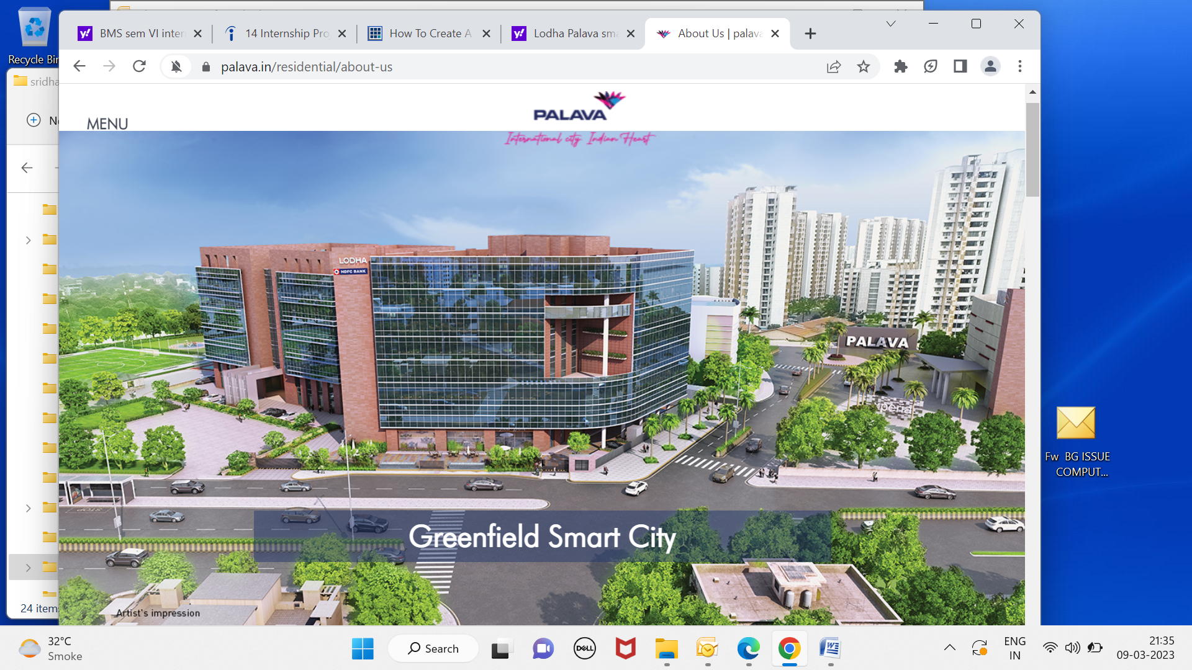

Spread over 4,500 acres, Palava is home to over 33,000 families. With a range of international standard facilities including world-class educational institutions, high-quality sports facilities at Olympic Sports Complex, a 5 lac sq. ft. Xperia Mall, a high-quality pedestrian friendly environment, grand clubhouses, community spaces and more, it is truly an International City with an Indian heart
Palava was developed as a private sector solution to the urbanisation challenges of the developing world. It is envisioned to become the largest ever privately planned development in urban India and among the world’s top 50 cities
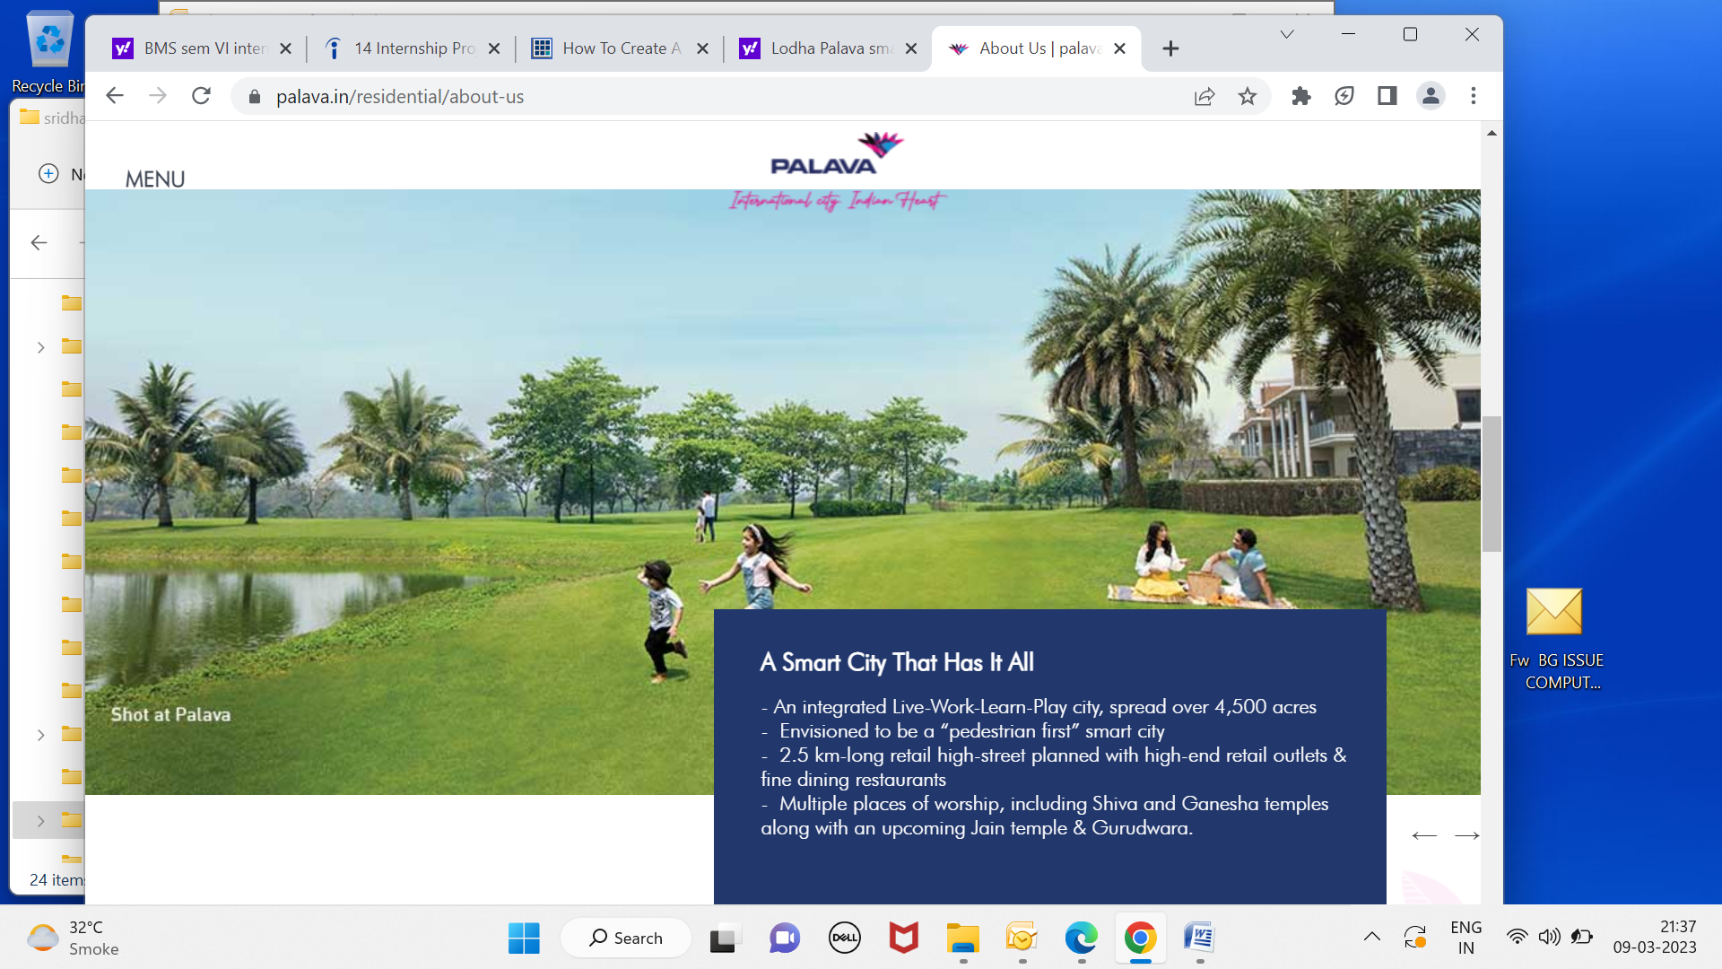

Services to be deployed :
A IP telephony
Residents in any cluster, need to have campus telephony service which can cater to connectivity to their helpdesk, healthcare services, transport, security and also with other residents staying in the same cluster.
Lodha Developers have opted for the latest technology wherein telephony will run on IP infrastructure which is centralised for that cluster.

B Access control :
Each of these buildings have access control at their entrance and in order to allow incoming visitors to enter the building, the residents need to provide them access through their telephony network and hence access control network is integrated with telephony.

C Video and wifi services :
Each of the residence will have a video interface at the door, for security purposes, which has visual coverage of the external lobby area to identify the persons at the door. Further, wifi facility in the garden area and inside residences are provided for internet and internet driven services to be accessed by the residents.

D Smart meters for residential premises :
In these newly developed complexes, each building having meter room, with campus network LAN switch, which gets connected to various endpoints, such as wifi devices, smart meters (for water and electricity), adjoining building and society office over fiber infrastructure, and on account of criticality of these services, these devices are powered through uninterrupted power supplies (UPS)

E Video cameras for security :
Indoor and outdoor cameras are provisioned for each building complex, wherein, security officials and helpdesk, which is monitoring 24x7 by Lodha team, can get a visual view of the activities happening in and around the residential buildings with the video stream being stored in society office NVR recorders for future access.

Role of Pace Edge Technologies :
Pace edge as the system integrator needs to align their deployment as per the design (with redundancy, scalability, qualitative support and under service level agreement) which involves supply, installation, testing, commissioning and facility management handover of the infrastructure at the end of completion of each cluster.
A team with a skill set in deployment of Ethernet switches (for data, voice and video), passive cabling laying and termination (UTP and fiber), deployment of voice gateways to convert from IP to analog telephony, deployment of cameras (indoor and outdoor) and network monitoring, is stationed at the site. Further, the team needs to achieve project milestones, aligned with the developers timelines of handing over the buildings to PCMA team, who do the allocation of residences to customers based on building completion timelines pre-agreed with them.
At present, Pace edge has to handle a total of 37 buildings split into six clusters and approx 21 buildings have come to completion, in a span of one year starting Feb2022 till date ; The project milestone completion is exactly in sync with the project timelines of building handover commitments.
The operations team, at Pace Edge end, has to ensure compliance to the design worked out by Lodha design team, approved by a team of consultants, wherein issues such as
- Scalability -
for e.g telephony license per IP PBX server having provision for buffer add on phones

- Protection from environmental hazard :
devices such as outdoor cameras etc need to be IP67/68 compliance and also mounted in a secure environment so that theft etc can be avoided

- Site handling on 24x7 basis :
with the building network infra being handed over for residents, the problems of access control, telephony, wifi not working etc, need to be resolved on round the clock basis

- Infra damage challenges :
with the site being under-construction, the hassles such as road digging, power fluctuations , water seepage, lightning during rainy season, flooding etc can damage the fiber cables, and active components such as switches in the meter room and hence, need to be vigilant to avoid or minimise the damages occurring from such instances.

- Civil/electrical workfront readiness challenges :
As these buildings were made ready by the civil team, the electrical contractors have laid down the UTP cables from the residences to the shafts, for ensuring connectivity with the network devices to be deployed in the shaft.
However, changes in the design by the design team at Lodha end, at subsequent time period, has mandated rack deployments in different shafts, where, these pre-deployed UTP cables have not reached and hence, connectivity for telephones etc, gets badly delayed, even for ready residences for possession till the electrical team does not sort out the cable distance issues.
- Funds allocation and cost scale up due to project delays :
With developers operating at SITC (payments getting released on milestone basis such as supply, installation, testing and commissioning), the contractors such as Pace edge face liquidity in working capital issues, as building readiness delays can impact the installation process for the supplied material, thereby funds flow from Lodha, impacts the working capital of the firm.
This has a cascading effect, on provisioning new items to the site, for upcoming buildings, thereby the project can further get impacted on timelines.

B Facility Management at College of Engineering Pune, now becoming COEP Technological University with seven FMS engineers, handling IT infrastructure for the entire campus which consists of technologies such as 10G campus backbone, indoor and outdoor wifi for students and faculty, video conferencing w/ webex, Internet load balancing through Radware Link Load balancer, Cisco switching & routing etc
This being a Unitary University under Ministry of Higher Technical Education, Govt of Maharashtra located at Shivajinagar, Pune has over 4500 undergraduate Engineering students and 300 faculty has been a premier govt educational institution for more than 100 years
Site website : www.coep.org.in
Contract start date : 1st October 2020 and continuing
Site incharge : Mr Sumit Jadhav
Email : helpdesk@coep.ac.in

Facility Management Services include:

1. Network Management Services :

Network Management Services for IT Infrastructure shall include the following along with any other activity required to be done for the optimum utilization of the networks and ensuring the availability of applications:

Sr. | ACTIVITY DESCRIPTION
No.
1. | Monitoring of LAN & Wi-Fi daily. Manual testing, troubleshooting and reporting the
 | status to the In-charge at the location as required.
2. | Configuring/Reconfiguring of routers, firewalls, modems, switches, nodes, servers
 | etc. for network connectivity, as and when required.
3. | Checking, testing and rectification of link problems of LAN including fiber links, their
 | connectorisation, splicing, CAT 6 cabling crimping punching etc.
4. | Maintaining an updated inventory/asset list of complete IT network infrastructure
 | (Desktops, Laptops, Servers, Workstations, Switches, Routers, Load Balancer,
 | Wireless Access Points, Firewall, all Active and Passive Networking Components).
5. | Maintaining an updated document for LAN/Wi-Fi network diagrams with relevant
 | details.
6. | Providing services for link/devices augmentation/deletion, relocation/connection/
 | disconnection etc., as and when required.
7. | Making protocol migration, as and when required. Protocol configuration on any new
 | router / switch as per the existing routing protocol.
8. | Maintaining and updating IP address list & optimum management of IP addresses
 | through DHCP/Static entry, whichever is suitable depending upon the COEP
 | requirements.
9. | Maintaining and running the Domain Controller with rights and passwords
10. | Netting / Sub-netting of the network IP s
11. | Ensuring that the network is Virus, Trojan and spyware-free and secure
12. | Carrying out maintenance, updation and configuration of the firewall for security and
 | maintenance, updation, successful Installation, commissioning and testing of the
 | McAfee Antivirus system to protect the Internet gateway, mail and network servers,
 | storage systems, and clients.
13. | Carrying out maintenance of the Active Directory policies as and when required.

- Wireless Network Management System

  - The Bidder/agency/firm shall configure, monitor, and troubleshoot the wireless network.

  - The wireless network needs to be properly configured for hot spots and prevention of unauthorized access.

- Desktop/Laptop/Workstation Management Services:

The Bidder/agency/firm shall provide technical support for all desktops, laptops and workstations. This includes installation and re-installation, adding, configuring, and loading of software applications.

Facility management services for PCs shall include the following along with all other actions which are necessary for optimum utilization of the PCs.

Sr. | ACTIVITY DESCRIPTION
No.
1. | Maintaining and installing any desired OS, desktop /client software, etc, as and when
 | required and provide services such as adding or removing accessories attachment or
 | other devices /peripherals.
2. | Configuring of a print server and resolving all printing problems of users.
3. | Arranging /downloading from internet and loading of drivers of peripherals, as and
 | when need arises.
4. | Configuring/reconfiguring client machines to ensure optimum network connectivity
 | and applications/service availability to all users.
5. | Installing, reloading, reconfiguring of any desktop/office automation software-mail
 | clients, browsers, applications, clients of any application etc., as and when required.
6. | Re-establishing the network connectivity and application availability after any
 | hardware/software failure.
7. | Providing services for all software bug fixes, patches, upgrades from the internet or
 | the concerned software principals, wherever fresh purchase is not required.
8. | Making applications of bug fixes, updates, upgrades provided by COEP or by
 | downloading the same, if need arises.
9. | Maintaining and ensuring proper working of all scanners and printers attached to the
 | PCs or LAN.
10. | Maintaining web cameras and all other peripheral devices that are part of IT facility of
 | the institute.

4. Security Management Services:

(COEP will provide a licensed Anti-virus software and the requisite infrastructure like server, etc. to run an Anti-virus tool)

To provide and maintain an effective control mechanism for viruses, Trojans and spywares on the network, desktops / laptops and servers with automated online anti-virus signature update facility. Any up-gradation of software such as antivirus signatures, etc. in the data center shall be the responsibility of the Bidder / agency / firm during the entire period of FMS.

The Bidder /agency /firm has to ensure that the entire network including servers, PCs, workstations and laptops remains virus/worm free.

Sr. | ACTIVITY DESCRIPTION
No.

  - The entire network shall be protected against viruses, worms, malwares, adwares, etc. Diagnosing and rectifying any virus problems. Escalating the problem cases to OEM of anti-virus signature database.

  - The latest anti-virus updates / patches shall be required to be made available to all desktops and online antivirus update facility to the desktop shall have to be created.

- Server Management Services:

    - Providing technical support to manage servers end to end like server administration, fine tuning, hardware and software support and upkeep of the server.

    - Handling of OS related issues, installation of OS upgrades, service packs and patches, re-installing OS if required, periodic system performance tuning, monitoring server usage statistics, network OS support and start up and shut down of servers.

    - Carrying out addition, deletion, re-configuration of devices, additional users and printers and housekeeping of servers such as disk space usage, files and folders, permissions, user logins on network, e-mail systems, etc.

    - Implementing security on servers at all levels.

Services related to Servers, Systems and Databases

- Windows Servers Operating Systems (operation and administration of Microsoft Server 2003R2, Windows Server 2008R2 and Advanced editions including Clustered environments acting as Domain controllers or Stand-alone servers)

- Unix Type Operating Systems platforms related to AIX, Solaris, Linux, and Open source distributions software

- E-Mail Systems (operation and administration of e-mail servers)

- Database Systems (operation and administration of Microsoft SQL, Oracle, mySQL and open source Database servers) and database server monitoring, maintenance, backup scheduling, storage management and performance issues

- IT Security and Operation Systems (operation and administration of systems that operate, monitor and maintain IT Security and Operations)
- Storage Systems (operation, administration and maintenance of Storage Area Networks (SAN) and Network Attached Storage (NAS), Distributed File System (DFS), Samba and NFS, quota management) if get implemented with the help of bidder/agency/firm.

- The Server Configuration support and maintenance required for all computer /IT Applications (over Internet/ Intranet), web, proxy and DNS, DHCP, LDAP, WIKI, MOODLE, FOSS Server, kPoint Server, Digital Library software, Server Virtualization & Server Management, Private Cloud and Linux server administration.

6. OS Administration, Network Security and LAN Maintenance:

Operating System Administration, Network Security and LAN maintenance services shall be provided by the Bidder/agency/firm and shall include the following along with all other actions, which are necessary for optimum utilization of the Servers and ensure the availability of applications:

Sr. No. | ACTIVITY DESCRIPTION

- Daily monitoring of servers and troubleshooting. Resolving server operations problems, like system ‘hang’, hard disk crash, etc.

  - Backup and Recovery Management Services:

    - To ensure that a periodic backup and recovery of critical data is done at the data centre.

    - To ensure that all servers and important data are protected against data losses and further to cover all defined servers.

    - To perform a regular backup.

    - To label properly and housing of the media for identification and retrieval.

    - Conduct restoration exercises at pre-defined periodic intervals to check the availability of backed up data. Regular maintenance of all the media and the backup device on a monthly basis.

    - Back up of users’ data on need basis as per the guidelines defined by COEP.

    - Ensure proper scheduling and taking of backups during non–peak hours.

- To provide reports on backup and restoration logs (failed reasons), monthly report on planned backup & backups actually taken on, quarterly report on the number of restoration drill performed and percentage of success, the health status of media and drive.

Sr. No. | ACTIVITY DESCRIPTION

- Perform backup operations for the servers as per defined backup Strategy/schedule, as specified by COEP at the site.

- Ensuring secure storage and handling of media to prevent data loss.

- Conduct restoration drills with sample backed up data every quarter to confirm data integrity.

- Application Management Services:

  - Integration and support of IT applications.

  - Management and maintenance of COEP website

  - Provide technical support and liaison with web developers in improving the COEP website.

- Management of IP Telephony Systems

The field comprises technologies such as tele / video-conferencing, VoIP.

Provide technical support for video and tele-conferencing infrastructures, trouble-shooting, evaluation and testing, documentation.

- Installation & configuration and maintenance of Internet Link Load Balancing System (Radware Alteon 5208S).

Provide technical support for future technologies, standards, applications and new technologies.

- End User Platform Management:

Management of end-user computer resources with software, hardware and network solution for office automation and desktop operations, technical assistance in software and hardware procurement.

- In case of any failure of hardware / network / software / supporting devices / internet leased line, bidder/agency/firm shall be responsible for communication with the concerned third parties.

- The Bidder/agency/firm shall be responsible for providing services even in the case of upgradation / replacement of software / hardware, etc. in the facility during the contract period.

- Preventive Maintenance:

The Bidder/agency/firm shall follow a strict preventive maintenance schedule, which must be carried out at least once in a quarter, for each machine.

The Bidder/agency/firm must ensure that he maintains a datasheet for each machine available, which will contain the configuration of each machine and dates of preventive/ breakdown maintenance carried out by the service provider.

The Bidder/agency/firm shall feed the record of completed service report, along with signature obtained from user ensuring satisfactory completion of the job.

Preventive Maintenance shall constitute the following:

Sr. No. | ACTIVITY DESCRIPTION
1. | Physical inspection and checking of all the hardware covered under this contract.
3. | Checking of all network points for proper connection, power condition etc.
4. | Checking and submit the status of UPS for all CISCO switches and data center.
5. | Immediately inform the concerned user in case of any impending crash of hard disk
 | so that remedial action for taking data backup could be initiated.
6. | Repair of registry and removal of the remnant of viruses / worms, incompletely un-
 | installed or deleted programmes etc.
7. | Checking of virus & removal of viruses if any, are found.

15. Manpower Deployment:

- Manpower Deployment:

To depute SEVEN qualified persons from Monday to Friday and five persons on Saturday to work at COEP campus. In addition, the bidder/agency/firm will also ensure that TWO qualified persons are available on the campus on all non-working days / Govt. holidays (Five and two persons made available on Saturday and holidays respectively shall be from same group of seven persons deputed on working days). It will be the responsibility of the Bidder/agency/firm to provide a suitable replacement in absentee of deployed persons as mentioned above.

  - It will also be the responsibility of Bidder/agency/firm to ensure that all labor laws (related to leaves, salary, provident fund, ESIC wherever applicable, medical benefits, working hours and conditions including Workman Compensation Act etc.) are complied with as per the government norms for the employees deployed at COEP.

C Facility management at Lodha Palava sector 3,
consists of Residential housing project with fiber to home (FTTH), with access control, video telephony running on IP, connectivity to smart meters with network supporting Power over ethernet etc

FTTH
With multiple Internet service providers such as Reliance Jio, Tata Communications, Airtel etc being in the fray to tap a large residential market, fiber to Home, has become a sort of mandatory offering from Real Estate developers for such housing projects.
The real estate developers has realised that Internet availability, with bandwidth, reliability, scalability, flexibility and cost-effectiveness for residential premises, has become not only a basic necessity, but a UNIQUE selling proposition (USP)
Hence, these developers have planned the basic IT infrastructure within those smart city complexes, with 4 core fiber running to each of the residences and offering one core of fiber link to a separate service provider like JIO or Tata play, to run their ISP services
Pace Edge Technologies, having a large manpower support, expertise in fiber and UTP (unshielded twisted pair / shielded twisted pair cabling) laying, coupled with offering add on IP based services such as telephony, wifi etc, have found a highly encouraging market, to work as contractors for these large scale developers and have been able to leverage their technological expertise in internet based services, to offer cost effective deployment for these residential complexes, by adhering to their building / flat possession timelines

Present work for Pace edge :
M/s Lodha Developers has issued a facility management worksorder to M/s Pace Edge, to maintain the fiber to home infrastructure, which was previously completed by Pace edge, as a project to provision the 4 core fiber to each of the residences of 76 buildings in sector-3 of Lodha Palava Khoni Project.
The objective of 4 core fiber to individual residence, was to allow upto four Internet service providers such as Reliance jio, Tata play, Airtel etc, to run their services such as IP TV, internet, wifi and so on using single core for their purpose.
Now, as this deployment was post completion of building handover, this retrofit operation, even though there were conduits which were provisioned for each of the residences, in multiple flats, it was found that the conduits are blocked and hence, under the previous FTTH project, Pace Edge could manage to deploy fiber only in 30-40% of the flats and for other flats, those cables were provisioned inside the duct outside each of the residence.
Under facility management contract, Pace Edge team, has to engage with Palava PCMA team, who raise tickets for calls to be handled, which are initiated either by the residents or PCMA team, as and when a new resident occupies the house OR existing residence faces connectivity problem for internet and issue needs to be resolved.
Pace edge site management team, deputes fiber laying personnel, to the residence and they pull the fiber, which is already positioned in the duct outside each of the residences, through pre-laid conduits (if not found blocked) and ensures internet connectivity at the residence.
In the event the conduits are found blocked, Pace edge team reverts to Lodha PCMA team, seeking their electrical team support to clear the conduits and them lays the fiber cable from the duct to inside residence, by terminating the same onto the DB box.
Facility management duration :
This facility management is spanning for a period of three years starting 1st July 2020 till 30th June 2023
However, as this sector occupancy is merely around 40% as on date, Lodha Palava may need to extend the contract to Pace Edge for another 1-2 years, to enable activation of fiber services to residences on as and when basis
Further, due to budget constraints, the original envisaged supplies of 192 kms of fiber, was utilised for 64 buildings out of the designated 77 buildings, which may necessitate phase II ordering of FTTH project from Lodha Palava to Pace Edge, for completion of balance 13 buildings, in the months to come.

1.12 SERVICES

In year 2017, Pace Edge Technologies decisively shifted their focus to realty sector which has been growing at a rapid pace wherein large scale projects were coming up, in the outskirts of the city as townships or Smart cities , but having an excellent connectivity through rail, road/highways and lately metros across the region.
Also, these projects, which were first time, being called as Smart Cities – such as Palava Smart city, in the area of Dombivali-Kalyan Municipal Corporation, Luxury Resort Living such as Lodha Belmondo at the outskirts of Pune city (near Sahara Cricket stadium) etc
These top developers having started developing Smart cities with sector wise development and having value-for-money preposition for potential buyers as there has been a growing need for small surface area housing with wide variety of amenities and is affordable to masses, which provides these developers economies of scale.
However, what apparently stands out is the fact that due to outskirts of the main city location, large mass of land is available for offering free open spaces, gardens, cafeterias, jogging tracks, which has made these projects attractive
As there are various technologies being deployed by these developers in these residential housing projects, there is a major scope for system integrators such as Pace Edge Technologies, to be involved in these time staggered large scale projects and with this approach, they have been able to carve their niche as system integrator, with top realty developer M/s Lodha Group for the ongoing Palava Smart City project/s.
In order to cater to these projects, they have opted to carry out operations from their Thane branch office, with spare equipments, fiber splicing devices, manpower to lay down IP infrastructure such as fiber / copper based cabling inside the Palava campus, deploying devices such as LAN switches, powering devices such as wifi (wireless), indoor / outdoor cameras, deploying access control for residents to offer security.

